**KUBERNETES TASK 7  
=======================**

Task 1: Execute all yaml files shown in video.

Taint Effects

NoSchedule

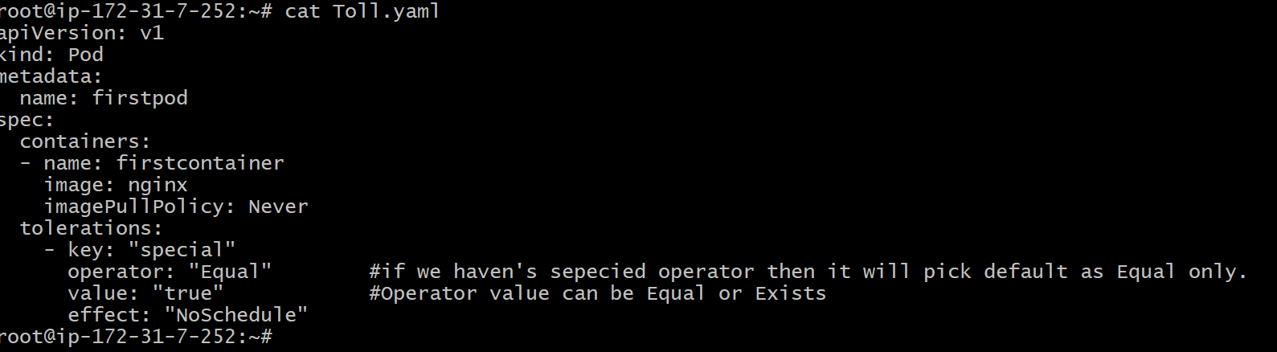

NoExecute

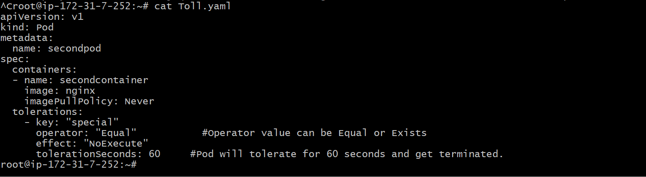

NodeSelector

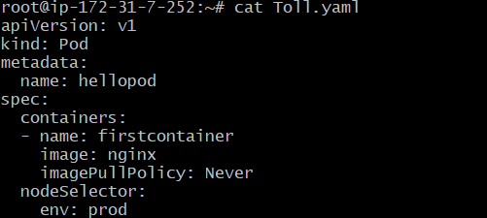

NodeAffinity

Soft Scheduling----it has 2 types---**PreferredDuringSchedulingIgnoreDuringExecution**

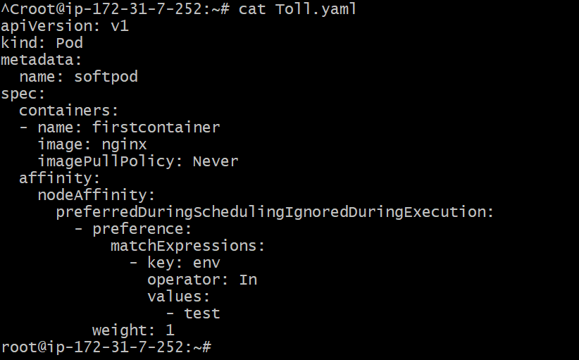

Hard Scheduling----it has 2 types---**RequireDuringSchedulingIgnoreDuringExecution**

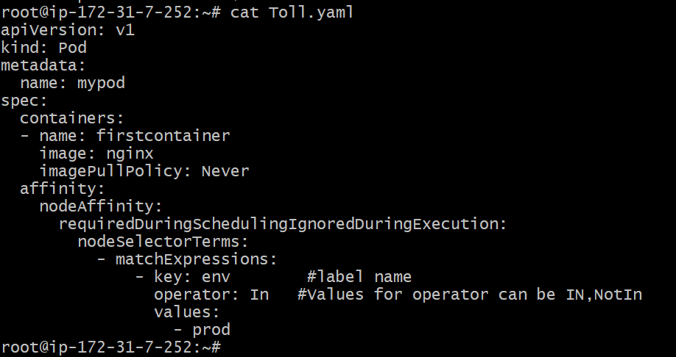

Task 2: Taint a Node and Schedule a Tolerant Pod Taint a node with special=true:NoSchedule. Create a pod with a toleration that matches the taint, allowing it to be scheduled on the tainted node.

First we need to create yaml file for toleration

Vi Toll.yaml

Cat Toll.yaml



After use this command to apply

kubectl apply -f Toll.yaml

to view total labels

kubectl get pods -o wide

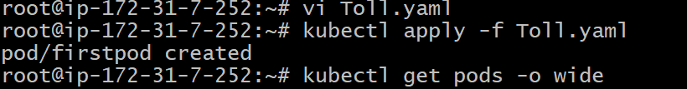

Task 3: Use NodeSelector to Schedule a Pod on a Specific Node Label a node with env=dev. Create a pod with a nodeSelector that schedules it only on the node labeled env=dev.

Before doing NoSelector we need to untaint all and this will add env=prod

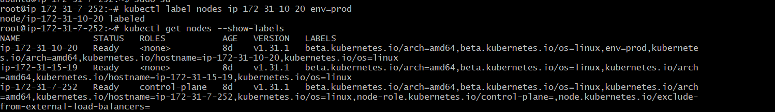

Vi Toll.yaml

Cat Toll.yaml



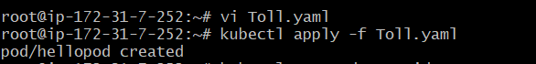



Task 4: Use Node Affinity with Soft Scheduling Label a node with env=test. Create a pod with.





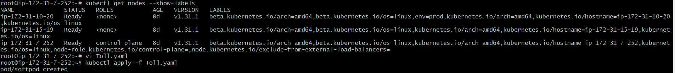



Task 5: Implement Node Affinity with Hard Scheduling Create a pod with RequiredDuringSchedulingIgnoredDuringExecution node affinity, ensuring it will only be scheduled on a node labeled env=prod. Verify the pod cannot be scheduled if no node has the env=prod label.

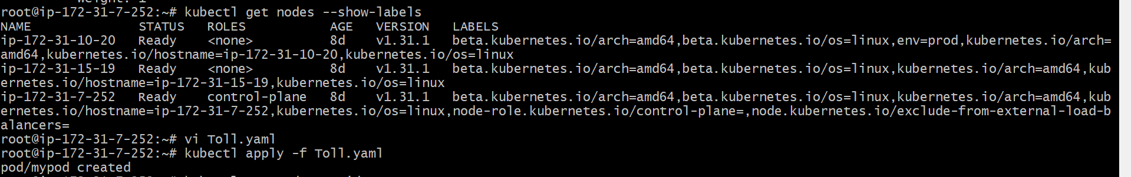

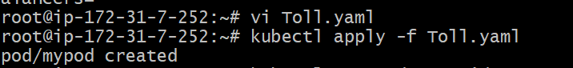





Task 6: Taint a Node and Use NoExecute with Toleration Seconds Taint a node with special=true:NoExecute. Create a pod with a tolerationSeconds field (e.g., 60 seconds) and observe it gets evicted after 60 seconds on the tainted node.

First we need to create yaml file for toleration and to taint also

Vi Toll.yaml

Cat Toll.yaml



After use this command to apply

kubectl apply -f Toll.yaml

to view total labels

kubectl get pods -o wide

now this will goes under worker 2 and we need to taint use this command

kubectl taint nodes nodename special=true:NoExecute

